**What is YOLO in Computer Vision?**

**YOLO** stands for **You Only Look Once**. It's a type of computer vision model that's used to detect objects in images or videos. The main idea is that it can identify and locate multiple objects within a single glance (hence the name "You Only Look Once").

**Definition**

YOLO is an object detection system that uses a single neural network to predict bounding boxes and class probabilities for multiple objects in one image. Instead of processing the image multiple times for each object, it does everything in one go.

**How YOLO Works**

1. **Image Division**: YOLO divides the input image into a grid.

2. **Bounding Box Predictions**: For each grid cell, YOLO predicts a fixed number of bounding boxes and their confidence scores.

3. **Class Prediction**: For each bounding box, it predicts the probability of each class (e.g., dog, cat, car).

4. **Thresholding**: It filters out boxes with low confidence scores.

5. **Non-Maximum Suppression**: It ensures that only the best bounding boxes for each object are kept.

**Backstory**

YOLO was introduced by Joseph Redmon and colleagues in a 2015 research paper. The goal was to create a faster object detection system compared to previous methods. Before YOLO, systems like R-CNN (Regions with Convolutional Neural Networks) would look at an image in multiple steps or regions, making them slower.

YOLO's innovation was to handle the entire image in a single pass through the neural network, making it much faster without sacrificing too much accuracy. Since its introduction, YOLO has seen multiple versions (YOLOv2, YOLOv3, YOLOv4, and more recently, YOLOv5) with improvements in speed and accuracy.

**Why YOLO is Important**

1. **Speed**: YOLO is extremely fast because it processes the entire image at once.

2. **Real-Time Detection**: It's capable of detecting objects in real-time, making it useful for applications like self-driving cars, security systems, and augmented reality.

3. **Simplicity**: YOLO’s architecture is relatively simple and easy to implement compared to other object detection methods.

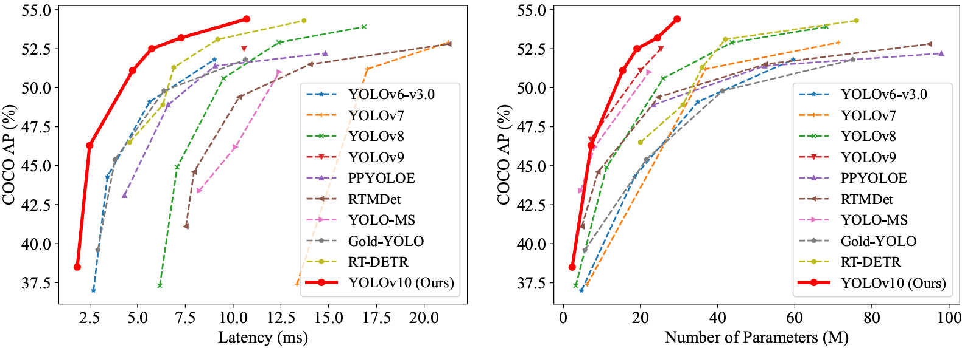

**YOLOv10: Real-Time End-to-End Object Detection**

**Introduction**

Real-time object detection is a crucial aspect of computer vision, essential for applications like autonomous driving, robot navigation, and object tracking. YOLO (You Only Look Once) models have become prominent due to their balance between performance and efficiency. Despite their success, there are still areas for improvement, particularly in reducing computational redundancy and optimizing model components for better accuracy and speed.

**Key Concepts and Challenges**

**YOLO Models**

- **Architecture**: YOLO models process images in a single pass to detect objects, making them faster than many other object detection systems.

- **Non-Maximum Suppression (NMS)**: This technique is used in post-processing to filter out redundant detections, but it adds to the inference latency and complicates end-to-end deployment.

**Issues with Current YOLO Models**

1. **Dependence on NMS**: The need for NMS slows down inference and makes performance sensitive to its hyperparameters.

2. **Architectural Redundancy**: Current YOLO designs have not been thoroughly optimized, leading to unnecessary computational load and less efficient parameter utilization.

**YOLOv10 Enhancements**

**Post-Processing Optimization**

- **Consistent Dual Assignments**: This approach removes the need for NMS by ensuring consistent and rich supervision during training, leading to competitive performance and lower latency during inference.

**Model Architecture Optimization**

- **Holistic Efficiency-Accuracy Design**: YOLOv10 comprehensively revises various components of the model to improve both efficiency and accuracy:

- **Lightweight Classification Head**: Reduces computational load while maintaining accuracy.

- **Spatial-Channel Decoupled Downsampling**: Enhances efficiency by separating spatial and channel processing.

- **Rank-Guided Block Design**: Minimizes computational redundancy for more efficient architecture.

- **Large-Kernel Convolution**: Improves feature extraction capabilities.

- **Partial Self-Attention Module**: Enhances model capability with minimal additional cost.

**Performance Improvements**

YOLOv10 shows significant improvements over previous models:

**- Speed**: YOLOv10-S is 1.8 times faster than RT-DETR-R18 with similar accuracy.

- **Parameter Efficiency**: YOLOv10 models have fewer parameters and FLOPs (Floating Point Operations), leading to faster and more efficient performance.

- **Latency Reduction**: YOLOv10-B reduces latency by 46% compared to YOLOv9-C while maintaining the same performance level.

**Code Availability**

The code for YOLOv10 is available at [https://github.com/THU-MIG/yolov10](https://github.com/THU-MIG/yolov10).

**Real-time Object Detectors**

Real-time object detection is a critical task in computer vision, aiming to classify and locate objects quickly and accurately. This capability is essential for applications such as autonomous driving, robot navigation, and object tracking. Over the years, numerous efforts have been made to develop efficient detectors that can operate under low latency. Among these, the YOLO (You Only Look Once) series has become the mainstream due to its balance of performance and efficiency.

1. **YOLO Series Evolution:**

- **YOLOv1, YOLOv2, and YOLOv3**: These versions established the typical detection architecture consisting of three main parts: backbone, neck, and head.

- **YOLOv4 and YOLOv5**: Introduced the CSPNet design to replace DarkNet, incorporated enhanced PAN (Path Aggregation Network), data augmentation strategies, and a variety of model scales.

- **YOLOv6**: Added BiC (BottleneckCSP) and SimCSPSPPF (Simplified CSP SPPF) for neck and backbone, respectively, and used anchor-aided training and self-distillation strategies.

- **YOLOv7**: Presented E-ELAN (Efficient Layer Aggregation Networks) for rich gradient flow and explored trainable bag-of-freebies methods.

- **YOLOv8**: Introduced the C2f building block for effective feature extraction and fusion.

- **Gold-YOLO**: Enhanced multi-scale feature fusion with the advanced GD mechanism.

- **YOLOv9**: Improved architecture with GELAN and augmented training processes using PGI.

**End-to-End Object Detectors**

End-to-end object detection has been a significant shift from traditional pipelines, aiming for more streamlined and efficient architectures.

1. **DETR and Variants**:

- **DETR**: Introduced the transformer architecture with Hungarian loss for one-to-one matching prediction, eliminating the need for hand-crafted components and post-processing.

- **Deformable-DETR**: Used a multi-scale deformable attention module to speed up convergence.

- **DINO**: Integrated contrastive denoising, mix query selection, and look forward twice schemes to enhance performance.

- **RT-DETR**: Designed an efficient hybrid encoder and proposed uncertainty-minimal query selection to improve both accuracy and latency.

2. **CNN-based End-to-End Detectors**:

- **Learnable NMS and Relation Networks**: Added another network layer to remove duplicate predictions.

- **OneNet and DeFCN**: Proposed one-to-one matching strategies to enable end-to-end object detection with fully convolutional networks.

- **FCOS**: Introduced a positive sample selector to choose optimal samples for prediction.

**Methodology**

Consistent Dual Assignments for NMS-free Training

To enhance efficiency and performance, a novel NMS-free training strategy is introduced for YOLOs.

1. **Dual Label Assignments**:

- **One-to-One Matching**: Each ground truth object is assigned to only one prediction, avoiding the need for NMS post-processing but often resulting in weak supervision.

- **One-to-Many Matching**: Provides richer supervisory signals by assigning multiple positive samples to each ground truth object, facilitating optimization and superior performance.

- **Combined Approach**: Incorporates both strategies by adding a second head to YOLOs that uses one-to-one matching during training. This dual approach allows the model to benefit from rich supervision during training and efficient prediction during inference by discarding the one-to-many head.

2. **Consistent Matching Metric**:

- Utilizes a uniform matching metric for both one-to-one and one-to-many branches, ensuring consistent optimization. This alignment helps the one-to-one head achieve better performance by following the same optimization direction as the one-to-many head.

Holistic Efficiency-Accuracy Driven Model Design

The model architecture is comprehensively redesigned to improve both efficiency and accuracy.

1. **Efficiency-driven Design**:

- **Lightweight Classification Head**: Reduces the complexity of the classification head using depthwise separable convolutions, which significantly decreases computational cost without harming performance.

- **Spatial-Channel Decoupled Downsampling**: Separates the spatial and channel transformations to reduce computational load and enhance information retention.

- **Rank-guided Block Design**: Utilizes intrinsic rank analysis to identify and reduce redundancy in different stages of the model, employing a compact inverted block (CIB) structure for stages with high redundancy.

2. **Accuracy-driven Design**:

- **Large-Kernel Convolution**: Enhances the receptive field and model capability by using large-kernel depthwise convolutions in deeper stages, combined with structural reparameterization to avoid optimization issues.

- **Partial Self-Attention (PSA)**: Introduces an efficient self-attention module that reduces computational complexity by processing only a portion of the features, thus incorporating global representation learning with low overhead.

**Experiments**

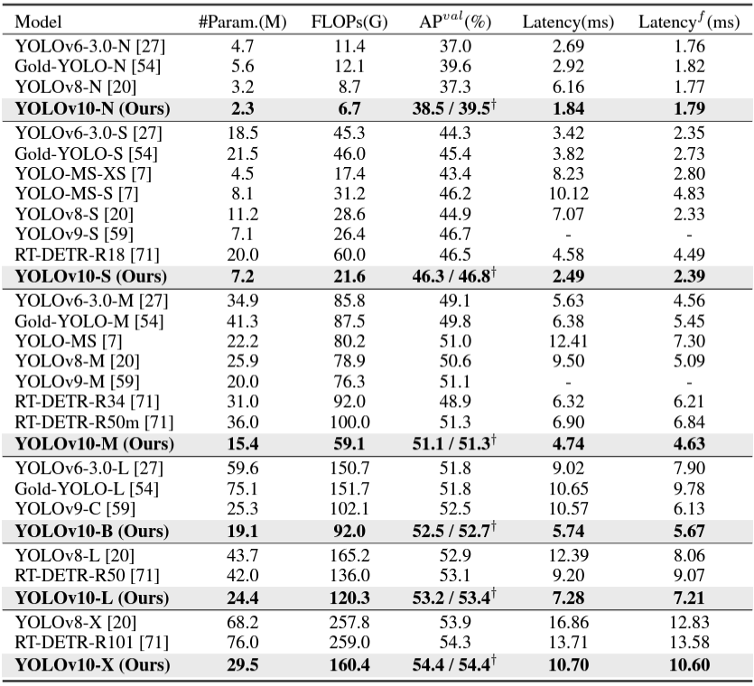

**Implementation Details**

**Baseline Model Selection:**

- **YOLOv8**: We chose YOLOv8 as our starting point because it provides a good balance between speed (latency) and accuracy. It also comes in different sizes, allowing us to compare different scales of models easily.

**Development of YOLOv10:**

- **NMS-Free Training**: Normally, Non-Maximum Suppression (NMS) is used to filter out overlapping detection boxes, but we developed a training method that doesn’t need this step by using consistent dual assignments.

- **Efficiency and Accuracy Design**: We designed the YOLOv10 models to be both efficient (fast and resource-light) and accurate.

**Variants of YOLOv10:**

- **Size Variants**: Just like YOLOv8, YOLOv10 comes in five sizes: N (Nano), S (Small), M (Medium), L (Large), and X (Extra Large).

- **New Variant (YOLOv10-B)**: This is a new variant we created by increasing the width scale of the YOLOv10-M model, making it wider and potentially more powerful.

**Model Verification:**

- **Dataset**: We tested YOLOv10 on the COCO dataset, which is a standard large-scale dataset for object detection.

- **Latency Measurement**: We measured the time it takes for the models to make predictions on a T4 GPU using TensorRT FP16, a tool that optimizes model performance.

**Comparison with State-of-the-Art Models**

**YOLOv10 vs YOLOv8:**

- **Performance Improvements**: YOLOv10 shows better average precision (AP) across all sizes compared to YOLOv8:

- **AP Improvements**: YOLOv10 achieves increases in AP ranging from 0.3% to 1.4%.

- **Parameter Reduction**: It uses up to 57% fewer parameters (the building blocks of the model).

- **Calculation Reduction**: It performs up to 38% fewer calculations, making it faster.

- **Latency Reduction**: The time taken for predictions is up to 70% lower.

**Comparison with Other YOLO Models:**

- **Lightweight and Small Models**: YOLOv10-N and YOLOv10-S outperform similar models like YOLOv6-3.0 and Gold-YOLO in terms of AP while being more efficient.

- **Medium Models**: Compared to models like YOLOv9-C and YOLO-MS, YOLOv10-B and YOLOv10-M show significant latency reductions with similar or better performance.

- **Large Models**: YOLOv10-L outperforms models like Gold-YOLO-L with fewer parameters and lower latency, improving AP by 1.4%.

**Model Analyses**

**Ablation Study (Component Testing):**

- **NMS-Free Training**: We found that using NMS-free training significantly reduced the model’s latency (time taken to make predictions) while keeping the performance almost the same.

- **Efficiency-Driven Design**: By incorporating various efficiency-focused design elements, we reduced the number of parameters and computations without sacrificing performance.

- **Accuracy-Driven Design**: Design changes aimed at improving accuracy led to significant AP improvements with only minimal increases in latency.

**Detailed Analyses:**

- **Dual Label Assignments**: This method uses two types of label assignments during training and testing:

- **One-to-Many (o2m)**: Used during training for rich supervision.

- **One-to-One (o2o)**: Used during inference for high efficiency.

- **Benefit**: This combined approach gives the best trade-off between AP and latency.

- **Consistent Matching Metric**: This aligns the one-to-one and one-to-many heads more closely, improving performance and reducing the need for extensive hyper-parameter tuning.

**Efficiency-Driven Design Elements:**

- **Lightweight Classification Head**: Simplifies the part of the model responsible for classifying detected objects, making the model faster without losing accuracy.

- **Spatial-Channel Decoupled Downsampling**: Reduces the image resolution in a way that retains more information, improving performance.

- **Compact Inverted Block (CIB)**: A more efficient building block for the model, which provides better performance with minimal overhead.

- **Rank-Guided Block Design**: Uses blocks adaptively based on their efficiency, enhancing overall model performance.

**Accuracy-Driven Design Elements:**

- **Large-Kernel Convolution**: Uses larger convolution kernels to capture more context in small models, improving accuracy.

- **Partial Self-Attention (PSA)**: Enhances the model’s ability to understand global context with minimal computational cost, boosting AP.

**Implementation Details of YOLOv10 Training and Evaluation**

**Training Setup**

1. **Optimizer and Training Duration**

**Optimizer**: Stochastic Gradient Descent (SGD)

**Training Epochs**: 500 epochs

**Momentum:** 0.937

**Weight Decay**: 0.0005 (5 × 10^-4)

1. **Learning Rate Schedule**

**Initial Learning Rate**: 0.01 (1 × 10^-2)

**Final Learning Rate**: 0.0001 (1 × 10^-4)

**Learning Rate Decay**: Linear decay from initial to final value

1. **Data Augmentation Techniques**

**Mosaic Augmentation**: Combines four training images into one

**Mixup Augmentation**: Blends two images and their labels

**Copy-Paste Augmentation**: Copies objects from one image and pastes them into another

**Training Environment**

**Hardware**: 8 NVIDIA 3090 GPUs

**Model Variants and Configurations**

**Model Variants**: YOLOv10-N, YOLOv10-S, YOLOv10-M, YOLOv10-B, YOLOv10-L, YOLOv10-X

**Width Scale Factor Adjustment**: Increased to 1.0 for YOLOv10-M to obtain YOLOv10-B

**Performance Evaluation**

1. **Metrics**

**Mean Average Precision (AP):** Standard metric across different object scales and IoU thresholds

**Speed Benchmark:** End-to-end speed evaluation

1. **Datasets**

**COCO Dataset:** Used for evaluating AP and latency on validation set

**Latency Measurement:** Performed on COCO validation set

1. **Post-Processing**

**Non-Maximum Suppression (NMS):** Uses TensorRT efficient NMS Plugin

**Latency Reporting:** Average latency across all images

